Non-paper on emergency wholesale price cap instruments for natural gas
This paper analyses two possible instruments of emergency wholesale price caps on gas in the context of a further supply disruption of natural gas supply from Russia in the autumn.
A first instrument would involve a price cap on imported gas from Russia and the second instrument would entail an administrative pricing during emergency in the particular European region affected most by the disruption of Russian supplies (‘red zone’) to prevent a spiralling of gas wholesale prices (and the contagion effect on wholesale electricity prices) .
This paper reflects the preliminary assessment and views of DG ENER only and should not be considered a Commission policy note including a final recommendation towards a specific course of action. It has not been shared with other services yet, nor has it received political validation of the Executive Vice President for the European Green Deal and of the Commissioner for Energy.
- Introduction
The May European Council invited the Commission to ‘explore also with our international partners ways to curb rising energy prices, including the feasibility of introducing temporary import price caps for gas when appropriate’. The Communication on ‘Short-Term Energy Market Interventions and Long-Term Improvements to the Electricity Market Design – a course for action’ already flagged the possibility of introducing an administrative price for gas (equivalent to a price cap) in the event of a “sudden large scale or even full disruption of the supplies of Russian gas”.
Since then, a number of different policy proposals have been put forward by the Commission to reduce both the risk and the costs for Europe in case of further or full disruption of Russian gas, strengthening European energy resilience. On 20 July the Commission proposed a new legislative tool and a European Gas Demand Reduction Plan, to reduce gas use in Europe by 15% until next spring. The Energy Council endorsed the target level and reached a political agreement on the new regulation on 26 July.
The Dutch Title Transfer Facility (TTF) gas contract prices are widely used in the EU gas markets as an index for long-term contracts. Its representativeness of the European gas market has been questioned in the last months due to bottlenecks in Northwestern Europe and its increasing deviation from Europe’s LNG delivered ex-ship (DES) indices. The Commission is preparing a policy proposal for the potential development of a complementary benchmark for the price of wholesale natural gas and exploring the benefits of subjecting the TTF to financial supervision. The options contained in this paper should take into account any measure impacting the wholesale gas index. A technical seminar on price caps for natural gas is scheduled with Member States on the 7th of September 2022 that will further look at the challenges related to the concrete operationalisation of the various price cap instruments.
- Two possible instruments for capping the cost of gas supplies in an emergency scenario
Price ceilings or price caps are a form of economic regulation which sets a limit on the prices that a provider can charge for their goods or services. It is usually linked to a market failure, e.g. a natural monopoly, the provision of a universal service obligation, or to provide common goods.
This paper examines the two main instruments identified during the technical work in the past months for an emergency scenario:
- Limiting the import price of Russian gas
- Applying and coordinating administrative pricing in a region most effected by the disruption of Russian suppliers
These instruments could be applied separately or cumulatively, as they are not dependent on each other and aim at different results.
Instrument 1: Limiting the import price of Russian gas via a price cap

- Problem/Objective
Under the current situation, Russia is maintaining revenues despite cuts in traded volumes as a result of the increasing EU gas prices. By reducing volumes and affecting prices (including by creating uncertainty), Russia is exercising monopolistic power on the supply of natural gas to Europe. At the same time, gas by pipe cannot be diverted easily to third countries. According to data from ENTSO-G Transparency Platform and the Centre for Research on Energy and Clean Air (CREA), Russian flows to Europe decreased by around 40% in June-22 compared to May-22 resulting in around EUR 1.5 billion of lost monthly revenues for Russia. However, in July-22 revenues from pipeline Russian gas grew by 4% compared with June-22.
The Russian gas price cap option would involve the introduction of a price limit for imports of Russian gas and provide certainty on prices and volumes in the market (if the agreement is expressed both in terms of prices/volumes). Its main aim would be to limit the revenues Russia earns from selling gas to Europe. It would also make it less attractive for Russia to trigger price increases via partial disruptions or market manipulations which would help to limit volatility and uncertainty on the gas market once the Russian price cap would be settled.
- Options
Different options would be possible:
- Introduce legislation to set-up a maximum price cap on the gas bought by Russia (close to the sanctions model)
- Create a single buyer entity that would negotiate specific volumes against specific prices with Russia
While a price cap would allow for lower import price for Russian gas and reduce Russian ability to influence prices and volatility, it might imply the activation of “force majeure” clause on existing gas supply contract which increases the likelihood of supply disruptions.
Ehrhart and Schlecht (2022) argue that under certain conditions an external price cap on Russian imports could be an optimal choice, under the following conditions:
- EU can credibly commit to stay firm following an initial Russian rejection of the price cap. The EU would have to be ready to give-up immediately Russian gas. Europe should not to take the gas market in isolation and assume Russia behaviour as a rational economic actor.
- The price cap should be designed in a way that Russia finds itself worse off under a gas delivery stop than complying with the price cap.

- Pros and cons
Introduction of a price cap on Russian gas | Pros | Cons
Impact on the EU | - Decreased volatility of prices  - Decreased costs for import of Russian gas if set below the average of import prices from Russia (LTC+spot) | - Risks of total disruption of supply from Russia as retaliation.  - Unevenly affects Member States depending on their exposure to Russia.  - If implemented via sanctions regime would require unanimity (while art 122 does not require it).
Impact on Russia | - Less incentive to manipulate prices  - Reduced revenues from gas exports | - Possible escalation of geopolitical tensions
Impact on markets | - Potentially increased certainty on Russian gas imports and prices allowing for longer term decisions  - Partially removing geopolitical uncertainty | - Might involve activation of “force majeure” clause in contracts

As to the concrete options for implementation, the implementation of a price cap on Russian gas via a maximum price (option (b) close to the sanctions regime), could be implemented in a quicker and simpler way that the establishment of a single buyer entity which might take a longer time to set-up. It would be challenging to develop the single entity (e.g. governance, capital, relationship with existing contracts…) in the very short term.
However, these options are not necessarily mutually exclusive and could be considered together: first the maximum price and over the long-term the creation of the single entity. The setting up of a single entity for buying Russian gas in the EU would be a very interesting long-term in the light of platform and the development of joint purchasing options.

Mechanisms to implement the cap on Russian gas | Pros | Cons
Option 2a: Max cap level (Sanctions tool) | - Easier and quicker to deploy and operationalise. | - Requires unanimity if done via the sanctions route.  - Need to explore if art 122 could cater for this option.
Option 2b: Single entity buying Russian gas for the EU | - Aligned with the joint purchasing objectives of the platform. | - Challenging to operationalise in the short term (capital, governance, contracts….).  - Requires compensation on private contracts.

The impacts of a legal imposition of a price cap on Russian gas imports on the current contracts with Gazprom are uncertain. It appears possible to argue that such a legislative change would not terminate the contractual obligations but first trigger a renegotiation of the existing contracts in light of the legal change on EU side, where EU importers could try to invoke “force majeure”. However, it is far from being clear that Gazprom would have to accept such change under the current contracts and this is a risk that would have to be considered in any decision.
Irrespective of the legal situation, the measure may be used by Russia to justify further disruptions under the existing contracts. At the same time, the recent reduction of Russian flows has reduced the level of influence Russian gas has in the overall EU market, with current flows from Russia being around one third of historical average. Lower flows from Russia makes the option of imposing a cap more compelling.
The instrument would have a more indirect impact, if at all, on gas prices as Russian pipeline gas is not always the price setter in the European gas market. Its main objective would be to
- reduce Russian revenues from natural gas trade with Europe,
- potentially increasing certainty on volumes and prices of the gas coming from Russia, and
- possibly reducing the uncertainty and volatility linked to Russia’s market manipulation
In terms of impact on security of supply, this measure would be of limited relevance once as a full disruption of Russian gas supplies is already a substantiated threat.

Level of the price cap
The level of the price cap would have to be aimed at the specificities of the Russian pipeline gas. The EU should make the price cap a better option for Russian than a complete stop of flows by making sure the price level can at least cover extraction costs and a minimal margin for profit. It would come at no direct cost to the EU (save for the cost in case of a complete halt of Russian supplies), and as such imply no financing or compensation measures. In addition, the cap on Russian gas would in line with the general strategy to reduce gas imports from Russia well before the end of the decade, with the risk that this comes earlier than being prepared for alternatives, including further risks to the economy until alternatives are found.
Regarding the cap level, the gas price cap should be fixed at a level higher than Russian production costs, so as to ensure that Russia does not benefit from higher revenues. Given that in the previous decade (2010/2020), prices of Russian gas have settled between €5 and €35/MWh, any cap above that level would ensure that Russia would be above its marginal production costs.
Dutch TTF prices: appropriate cap levels
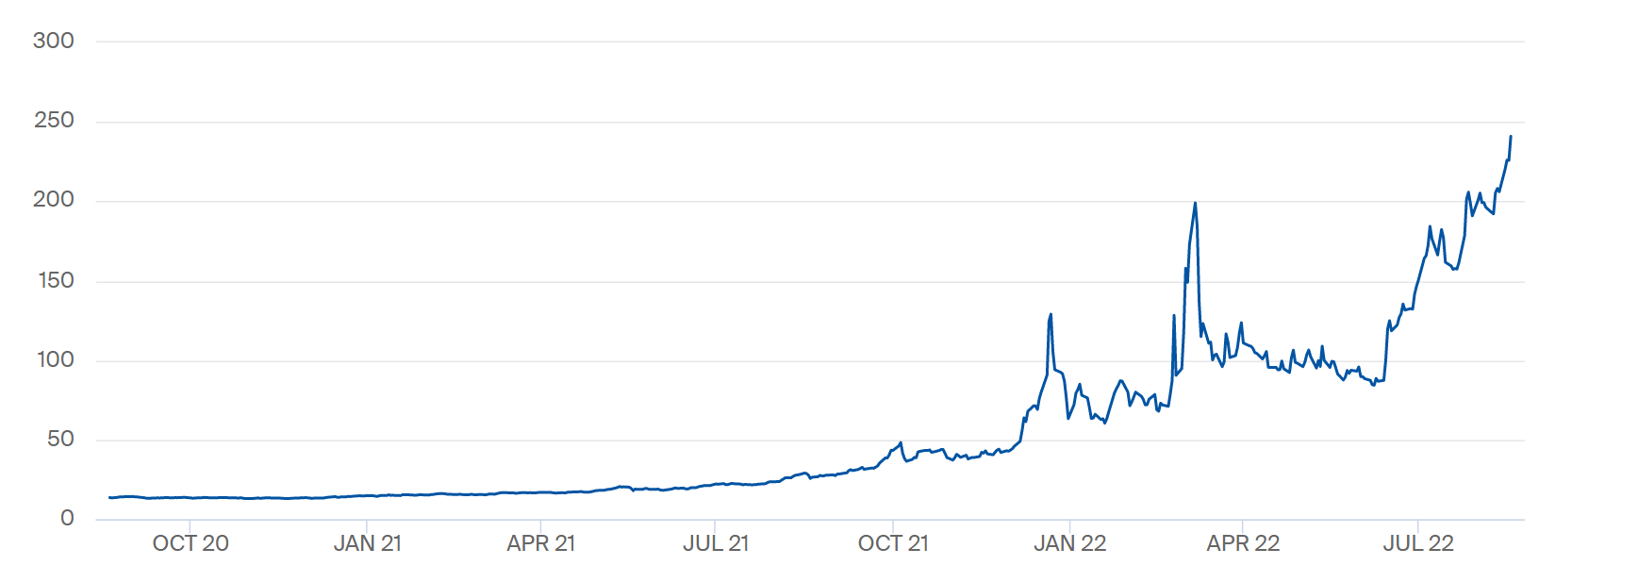
Therefore on pure economic terms, this could even be a better deal for Russia than the prices applied over the past decade. However, Russia does not behave like a market operator. Quite on the contrary, it has used gas as a weapon in the past years. In that sense, the credibility of the offer from Europe would only exist if the EU would be willing to give up completely Russian gas from day one.
It might have to be expressed as a maximum price to have the buy-in of those Member States receiving natural gas supplies from Russia at lower prices: gas bought to Russia by pipe is not bought on the spot markets but under Long Term Contracts where the actual price could be much lower than the market prices.

Best moment for introducing the cap on Russian natural gas
While the premise of the paper is that the measures described would be triggered by an emergency level, the decision on when to apply a possible cap on Russian gas is a political one as it mainly depends on how much the EU is willing to risk further/full disruption (there is a risk that the other side says no and nothing guarantees that they would keep the volumes stable). The EU would like to maximise volumes and minimise prices. The idea of the price cap on Russian natural gas would be to negotiate not only the price but a fixed volume of supply (simplifying 50 bcm/year at €50/MWh). The chosen moment will depend on the political appetite from Member States.
The introduction of the cap on Russian natural gas could therefore be introduced at any moment and even now. If agreed by Russia on both volumes and prices, a price cap on Russian imports of gas would provide more benefits before an emergency situation than after. In a regional emergency level only, gas from Russia could still flow but in even lower volumes than today; in that case, such a price cap could still produce an effect, but clearly its impact both on Russia and on our consumers, at wholesale or retail level, would be far smaller.
There is therefore a trade-off that has to be weighted between the risk of additional disruptions (the lower the current volumes of gas going forward, the lower the risk the EU incurs (RU is cutting supply anyway - if they do not supply much, why not risk it?) and the gains from introducing the cap.
Moreover, even in the case of full supply disruption, introducing the cap could make sense: it could be seen as a way to restart flows under new conditions more favourable to Europe.

Best moment for introducing the cap on Russian natural gas | Pros | Cons
Before emergency | Makes more sense economically if flows continue, gives the EU the initiative again and takes out the geopolitical risk form the equation | Higher economic risk if there is a full disruption
After emergency | Flows very much disrupted anyway so little additional risk | Lower economic impact if flows continue
After full supply disruption | no risk – flows have stopped anyway | no impact until flows restart

- Recommendation
While Russia has already considerably reduced gas flows to the EU, this option should only be considered if the EU is ready to accept a full disruption of Russian gas supplies. The added value of this measure is mainly on reducing Russian revenues and prices volatility rather than necessarily lowering EU gas prices (unless Russia would increase supplies) and should therefore been understood as a quasi-sanction measure against Russia.
Three policy interventions could be considered to increase the likelihood of Russian compliance with a price cap on Russian gas imports despite the risks of Russia valorising more political over economic rational.
- The EU should lock-in policy choices once a decision of imposing a price cap on Russian gas imports is achieved, i.e. not backing down in the event of Russian threats to completely stop the gas supplies to the EU as a result of the price cap.
- Under the risks for security of supply of a complete disruption of Russian gas as retaliation to the price cap, the EU should anticipate and mitigate the impact of a complete embargo by strengthening cohesion among Member States, stimulating curtailment and demand reduction, and mitigating the unnecessary spiralling in prices (see Instrument 2 on “Applying administrative pricing in a region most affected by the disruption of Russian suppliers”). This would make a gas embargo more bearable for the EU consequently strengthening the EU position in imposing a price cap.
- The EU should make the price cap a better option for Russian than an embargo by:
    - Making an embargo for Russia more painful, threatening with further sanctions in case Russia stops gas deliveries to the EU.
    - Make the price cap an acceptable option by ensuring a sufficiently high level to cover Russian extraction costs and reasonable profit margin.
The added value of the price cap on Russian gas imports is mainly to reduce Russian revenues and potential price volatility rather than lowering internal EU gas prices (TTF) and should therefore been looked at as a quasi-sanction measure against Russia. However, this option should only be considered if the EU is ready to accept a full disruption of Russian gas supplies, despite already reduced flows.
It is suggested to have further exchanges with Member States on the concrete challenges and implications of both options to impose a price cap on Russian gas and the desirability to implement them.
- Output (This would have to be checked by ENER legal unit with the LS.)
Depending on the instrument to be chosen (maximum price or single entity), different legal tools would be possible:
- Article 122 TFEU might be the legal tool that could allow the creation of a single entity to purchase Russian gas.
- However, if the intention is to fix a maximum import price, article 215 TFEU (legal basis of the sanctions regime) could potentially be considered. A discussion with FISMA on the legal feasibility would be necessary to establish the appropriate legal form to enforce the price cap on Russian gas.
It has to be noted that while the sanctions regime requires unanimity, art 122 is QMV.

Instrument 2: Applying administrative pricing in a region most affected by the disruption of Russian suppliers

- Problem
The disruption of Russian gas supplies impacts unevenly the security of supplies in different Member States. While some Member States do not depend on Russian gas supplies, others strongly rely on gas arriving from Russia. Member States with high dependency on Russian gas have often little means to switch to alternative supplies in the short term and would have to resort to drastic demand reduction and fuel-switch measures, in case of full supply disruption from Russia.
Russian gas supply disruptions are therefore likely to have different price implications in different regions. Member States with high dependency (e.g. in Central and Eastern Europe) could see their gas prices rise stronger than Member States which are less dependent (e.g. the Iberian Peninsula). More importantly, strong price increases in highly dependent Member States would not be able generate sufficient additional gas supplies from alternative sources mainly due to infrastructure constraints/bottlenecks and scarcity of gas supply in other markets.
In terms of wholesale gas prices, a certain divergence of regional European gas markets is already observable. It has to be noted that prices of different regional hubs in Europe have started to diverge significantly, while pricing in the different infrastructure bottlenecks and regional market perspectives. For delivery in September, gas is trading in Spain and France at around 60 €/MWh (!) discount to TTF while the discount for Belgium is around 40 €/MWh. Germany, Italy, Czech Republic, Slovak, Austria trade at a slight premium to TTF (presumably due to cost of transport).
- The objective
Some Member States might temporarily cap the wholesale price of gas as an emergency measure, in order to avoid an unnecessary spiralling in wholesale prices in their regional zone that would not attract additional gas (i.e. going to price levels which do not attract any volumes of additional gas while having a contagion effect on wholesale electricity prices with severe macroeconomic effects),
In distinguishing the regional zones, European regions could be labelled according to the severity of the impacts of the disruption with red (higher exposure to disruption) and green zones (lower exposure to disruption).The red zone would be made up of Member States where prices could strongly rise above the prices observed on TTF index following a full disruption of Russian gas supplies and eventually entering into the emergency level. This paper analyses the introduction of an administrative price with a cap in this whole area. However, the decision of implementing the cap would require the agreement of all Member States in the area. For the scheme to have a chance of working, it would require that the bigger Member States in the red zone are part of the scheme.

Box: The Title Transfer Facility (TTF)
The Title Transfer Facility (TTF), is a system registering the transfer of title to the gas delivered in the Dutch gas system. [n.b. a separate note looks at potential policy avenues related to the representative benchmarks for natural gas in the EU.]
The TTF is operated by the Dutch gas TSO, Gasunie Transport Services (GTS). Trading on the Dutch system is organized either bilaterally between traders (shippers) or through organized energy exchanges (such as The Intercontinental Exchange - ICE). By organising the notifications for physical delivery of gas, GTS merely facilitates the purchase and sale of gas on TTF.
While purely a national facility, TTF’s significance goes well beyond the Dutch system. Prices displayed for TTF are a reference for the rest of Europe. Shippers often manage price risks by transacting on the TTF or linking their prices in contracts to the TTF price even if they need to deliver gas elsewhere in Europe. This has made TTF the most liquid marketplace for gas in Europe. The TTF price is also often part of the price formulas in long-term gas contracts. Taken together all trades, including derivatives, annual trading volumes make up more than 100 times (!) the gas consumption in the Netherlands and are 10 times higher than the entire EU gas consumption. Around 80% of these trades are organized by ICE with the rest arranged for by brokers (so called over-the-counter trading - OTC). Most of this gas is traded in form of derivatives (mostly financial futures).

Depending on the specific circumstances of the energy imports mix and the supply disruption (full or partial covering different Member States), the red zone could include different groups of countries. Most likely this would concern countries in Central and Eastern Europe to different degrees. Depending on the seriousness of the situation (how broad the supply disruption is) this could expand to other countries like Germany and Italy and beyond.
The green zone(s) would be areas where prices would be below or equal to TTF prices (it has to be noted that recently due to the infrastructure bottlenecks in Northern Europe, prices have started to diverge compared to with other European regions).
The price cap on wholesale transactions in the red zone would be dynamic and be set in reference to the TTF price. Given the difficulties in predicting prices in a strongly volatile environment, a static price cap would be challenging to establish. Moreover, given the need to ensure that gas flows from the green to the red zone, and that the markets continue to function with their allocation benefits in parts of Europe, the prices in the red zone would have to be higher than in the green zone. The cap should be slightly above the TTF price to make sure that all available gas that the transmission system can carry actually flows to the red zone where the gas will be needed. The cap would be in this option a maximum price at which gas can be sold as there are many prices being applied (via long-term contracts) and others.
The analysis in this paper does not look at specific compensation measures since:
- The cap is established above market prices and continues to flow in the EU.
- Any adjustment is considered to be performed via demand reduction (and therefore any compensation is provided via demand reduction schemes – see separate paper on the coordination of demand reduction schemes).
Box: Why is a wholesale price cap for the whole of Europe not described in the paper?
Several Member States have flagged the possibility of applying a price cap in all gas exchanges in Europe. These proposals do not elaborate so far on the technical implementation. Two main operational questions remain: how gas would be allocated in these circumstances in Europe and, if the cap is set below market prices, how the measures would be compensated.
Moreover, given that some parts of the EU gas market would be unaffected from a supply disruption, it is not clear what would be the benefits of imposing a cap in areas not affected by the disruption from Russia, while the downsides from stopping the market functioning in the whole of the EU could be very considerable.
A separate paper looks at the possible measures related to the TTF and gas natural benchmarks. Additional models include separating LNG deliveries from pipeline ones, in order to impose a cap on the latter (which has less alternatives) while continuing to pay a premium for the former (for instance through auctions). This could include setting a price cap through the TSO’s balancing price (which would require accepting rationing); and/or regulating interval price limits at exchanges.
Important to note that this is different from the proposal to limit the impact of gas prices one electricity prices, which is the subject of other papers.

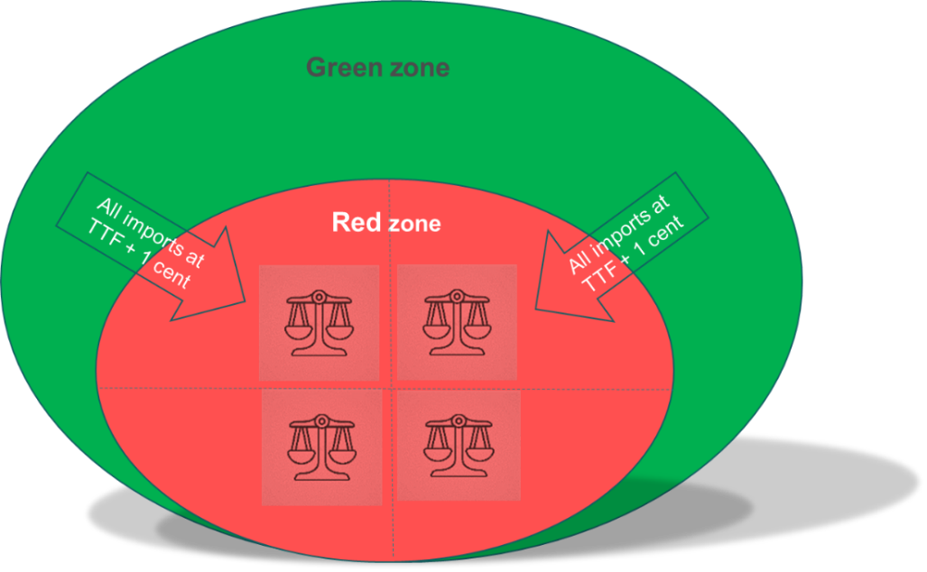

- Options

  - Uniform price cap within and between zones
Under this option supplies into the red zone would be prohibited from being priced above the price cap. This would apply to both, transactions between the green and the red zone and transactions within the red zone. As there would be no price differential within the red zone to indicate where gas should flow if the cap is reached, an administrative allocation key would need to be identified. This key could for example be a proportionate allocation of the ‘missing gas’ between the Member States in the red zone, meaning that each Member State would be able to receive gas from the green zone in proportion of its customer base (or following the last demand reduction package, based on the average consumption of the last five years).
Example: In a normal year MS1 has a gas consumption of 100, MS2 has 30 and MS3 has 20. Assume that due to supply disruptions, in a given period, all together 15 volumes of gas can arrive from the green zone. From this volume, based on an agreement between MS, MS1 would receive 10, MS2 would receive 3 and MS3 would receive 2.
Arranging flows in this way would require significant regulatory and technical complex preparations. Member States would need to align their existing emergency arrangements including coordinating the relevant work of their competent national authorities.
The Commission is working on two papers on reinforcing the EU Energy Platform Governance and revising the Energy Governance Regulation (Regulation (EU) 2018/1999). This work should be linked to the proposal of this instrument as it concurs in increasing cooperation among Member States.
There would be a need of defining governance arrangements on two levels:
- Technical: A ‘technical’ body to allocate volumes coming from the green zone between the Member States in the red zone based on objective criteria.
- Political: Given the important implications for the EU and MS economies, these decisions would have to be sanctioned at the level of Ministers/their representatives.
A technical body would be mandated by the Member States in the red zone to make sure that it follows common objectives and operates in line with agreed rules. This technical body could for example consist of national TSOs and market operators. The technical body would calculate available volumes for each Member State in the red zone. The volumes would then need to be contracted and shipped from the green zone to the Member States in the red zone. It would be up to Member States to determine which shippers and customers would be entitled to receive the allocated volumes. Alternatively, Member States could also provide that the procurement of the available gas in the green zone is centrally arranged on behalf of all Member Stes in the red zone. This would require the agreement of appropriate financial arrangements between the Member States.
In order to participate in the scheme, it would be required that participating Member States coordinate and fully implement agreed demand reduction measures aligned to a common previously defined merit order (to avoid any free-riding).
Given the difficult decisions to be taken related to gas allocation/demand reduction, the decisions would have to be sanctioned by appropriate Member States and European bodies. The Energy Council, or an appropriate body with representatives of the Member States (e.g. a Board at the level of Directors Generals) would be entrusted to sanction the decisions.
  - Uniform price cap between zones with possibility to trade
This option is an adjusted version of option a). It would apply the same approach for bringing gas into the red zone and allocating it within the zone. However, it would allow customers to trade the allocated gas between Member States inside the red zone at prices above the price cap. Such trade could take place through established marketplaces including through coupling of platforms which a number of Member States have set up to offer industrial gas users an opportunity to sell off the gas they do not wish to consume (please see the parallel paper on auctioning and demand reduction schemes).
It would be up to Member States to determine which shippers and customers would be entitled to receive the allocated volumes and which customers would be allowed to resell the gas. This model would for example allow for selected groups of customers to resell their allocated gas above the price cap, while keeping the cost of supplies to protected customers capped. Option b would thus be a hybrid model between ‘market pricing’ and ‘regulated/capped pricing’. Selected groups of customers, typically industrial users, would receive gas according to their willingness/ability to pay while protected customers would be supplied with price capped gas. While option b) might be less equitable than option a) it might increase the willingness of Member States with higher ability to pay to participate in the scheme. This is a critical element for these schemes to have a chance to function: the bigger economies in the possible red zone (e.g. Germany) would have to be in. Otherwise, there is a risk that if applying higher prices all gas would flow to Germany rendering the price cap in the red zone ineffective.
Both, option a) and b) face several challenges. They rely on the willingness and agreement of all Member States in the red zone to work. Member States who expect to receive less gas through a proportionate allocation when compared with the volumes they otherwise would be able to receive (and willing to pay for), might not be inclined to participate. This would, in turn, have major implications for the rest of the Member States in the red zone. For example, if Germany would decide not to participate in the scheme, a ‘TTF + 1 cent’ type of pricing would need to be adjusted to reflect the presumably higher wholesale gas prices in Germany. This would ultimately reduce the attractiveness of the entire scheme for the rest of the red zone.
It would also need to be clarified and agreed between the participating Member States how the calculations for the centrally arranged or coordinated imports from the green zone would accommodate contracts between the green and red zone which predate the introduction of the price cap.
The technical definition of criteria and governance mechanisms would be extremely complex and would increase with the number of participating Member States.

- Pros and cons vis-a-vis the existing market model without price cap
Pros:
- Allows for sharing the available gas in full solidarity (and the arrangements could potentially make the possibility of joint procurement easier).
- Helps avoiding the contagion to wholesale electricity prices and inflationary effects.
- Spreads the burden across Member States and allows for a better economic outcome at EU level (c.f. IMF paper).
Cons:
- Complex to administer and challenging to ensure that the gas will flow to where it is most needed. Needs to establish an entity helping to allocate gas. Increased complexity with a higher number of Member States participating.
- Need to ensure that it is properly implemented across Member States. Would require setting-up a whole new governance system for the participating Member States.
- Needs full coordination of demand reduction across the participating Member States (full application of demand reduction measures should be a pre-condition). It would require a joint merit order for all consumers, coordinated between regulators, under substantial uncertainty which could be politically very divisive.
- Depending on the intra-red zones, there could be a risk that some in the green zone could be tempted to “keep their gas” and limit exports to the red zone. A small intra-red zone price difference might not be an incentive enough to keep the borders open (see parallel paper on compensation and demand reduction measures).
- May need to be combined with the development of a (new) system of administrative retail prices to ensure benefits are passed on to consumers.
- Need to clarify how it impacts existing supply contracts. [n.b. Need confirmation that art 122 can supersede existing contracts]
- The relationship with the storage regulation has to be further developed (e.g. the gas provided at lower prices should be for essential use not for other purposes like re-selling it).

Box: retail price caps
Member States can also apply price cap for retail consumers. This is allowed in the Gas Directive. Such measure is used by Member States pre-crisis and is part of the existing toolbox at national level in the current context. In its May communication the Commission stressed that legal clarification as regards application of regulated prices for SMEs, also relevant for gas, could be provided. However, a price cap remains an auxiliary measure, it does not address costs of gas as input for the economy (and its inflationary effects) and electricity production and the fundamental questions raised in this paper. Also, the higher the wholesale price the bigger the costs to pay by the public budget or the supplier to finance such retail price cap.

- Recommendation
Given the numerous challenges linked to the effective implementation of the regional price cap scheme we propose to work closely with Member States to map the challenges and test the desirability of any possible scheme at the seminar on the 7th of September.
It would be critical to ensure a common understanding with Member States on pros and cons and the appropriate analytical basis. Any solution would require to accommodate their particularities and needs and to generate full ownership.
In order to secure the participation of Member States with higher ability to pay (e.g. Germany inside the red zone) a choice for option (b) might be more appropriate. Option (b) would provide for more flexibility to exchange gas between Member States while allowing for the cost of supplying protected customers to be kept in check.
- Output and concrete implementation
A scheme with a price cap concerning a group of Member States might be possible to address with an instrument under Article 122 TFEU.
In order to avoid Member States acting unilaterally, due to the impact that an action capping wholesale prices might have on its neighbours, the possible new article 122 instrument could make it mandatory that price cap measures as the ones described above have to be agreed and coordinated at European level (in particular by those Member States in the affected region). Moreover, these measures would only be imposed as a last resort measures and under certain conditions:
- Full implementation of agreed demand reduction measures under the gas SOS Regulation and July art 122 proposal.
- An obligation to fully coordinate demand reduction measures according to a pre-agreed merit order.
- Allow a cap that does not impede the flow of gas from red to green zone (requiring it to be above prices in the green zone)
- Contribute to the macroeconomic and financial stability of the Union (not put at risk the fiscal position of the Member States).

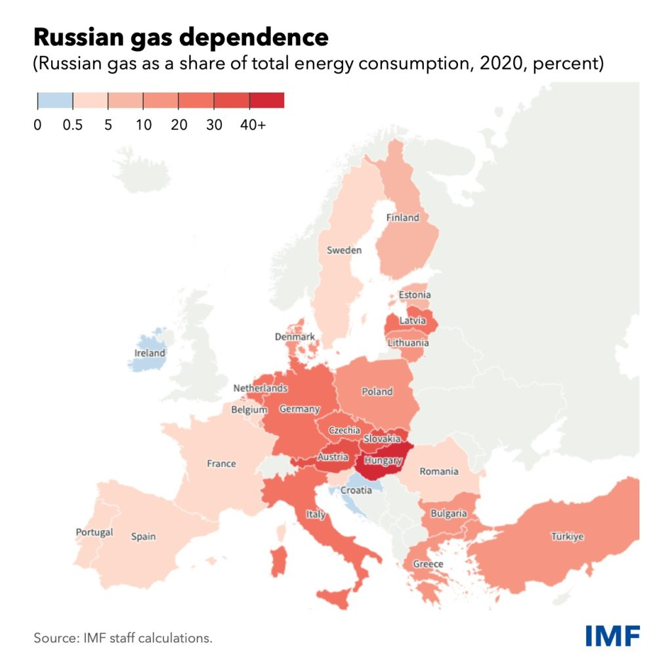
Illustration of a possible red zone. Its actual geographical demarcation would depend on the specific market conditions and the extent of the supply disruption

https://www.consilium.europa.eu/media/56562/2022-05-30-31-euco-conclusions.pdf
COM(2022) 236 of 18 May 2022
Save Gas for a Safe Winter (europa.eu)
The development of a new complementary benchmark representative of the European gas market could result in an additional reference index for wholesale prices, further increasing the economic gains of Instrument 2.
https://crea.shinyapps.io/russia_counter/?tab=methodology
Ehrhart, Karl-Martin; Schlecht, Ingmar (2022): Introducing a price cap on Russian gas: A game theoretic analysis, ZBW – Leibniz Information Centre for Economics, Kiel, Hamburg
The Japan Korea Marker (JKM) is the Liquified Natural Gas (LNG) benchmark price assessment for spot physical cargoes. JKM reflects the spot market value of cargoes delivered into Japan, South Korea, China and Taiwan.
For the purpose of graphically describing this situation: Prices in the red zone could double temporarily the price in the green(er) zones but despite the increase in prices supply would not increase due to scarcity in the system. Today TTF are at a level around 230€/MWh. While this level of prices would continue in the green zone, prices in the red zone, could move towards prices above 400€/MWh and higher.
For graphic purposes: under this option, if the green zone trades at TTF prices, the trade between green and red would trade at TTF+1 and the trade inside the red zone would be at TTF+2.
The regulatory means of introducing such a measure would have to be analysed further.

